ANALYSIS AND INTERPRETATION
Variable | Category | Frequency | %
Current level of study | Postgraduate | 174 | 46.8%
 | Undergraduate | 198 | 53.2%
Which aspect enhances compliance most | Availability of safety equipment | 92 | 24.7%
 | Clear communication | 101 | 27.2%
 | Punitive measures for non-compliance | 25 | 6.7%
 | Regular training | 81 | 21.8%
 | Visible signage | 73 | 19.6%
How often come across cleanliness/safety | Always | 48 | 12.9%
 | Never | 6 | 1.6%
 | Often | 77 | 20.7%
 | Rarely | 116 | 31.2%
 | Sometimes | 125 | 33.6%
Institution conducts safety checks | Never | 19 | 5.1%
 | Not sure | 41 | 11.0%
 | Occasionally | 128 | 34.4%
 | Rarely | 145 | 39.0%
 | Regularly | 39 | 10.5%
How often informed about safety issues | Immediately | 62 | 16.7%
 | Monthly | 64 | 17.2%
 | Never | 149 | 40.1%
 | Quarterly | 97 | 26.1%
Trained or informed about safety | No | 158 | 42.5%
 | Partially | 132 | 35.5%
 | Yes | 82 | 22.0%
Ever witnessed/been in incident | No | 299 | 80.4%
 | Yes | 73 | 19.6%
Enough emergency measures? | No | 67 | 18.0%
 | Not sure | 211 | 56.7%
 | Yes | 91 | 24.5%
 | yes (duplicate entry) | 3 | 0.8%
Control measures present | No | 323 | 86.8%
 | Yes | 49 | 13.2%
Safe places within campus | No | 331 | 89.0%
 | Yes | 41 | 11.0%

Table 1: Frequencies – Student Dataset (n=372)
Variable | N | Mean | Std Dev | Min | Max | Interpretation
Familiar with H&S | 372 | 3.08 | 1.18 | 1 | 5 | Moderate familiarity
Confidence in knowledge | 372 | 3.24 | 1.06 | 1 | 5 | Slightly above moderate
Effectiveness of current measures | 372 | 3.19 | 0.90 | 1 | 5 | Moderate effectiveness
Rating of institution’s safety | 372 | 3.10 | 1.05 | 1 | 5 | Neutral to slightly positive
Overall feeling of safety | 372 | 3.44 | 1.00 | 1 | 5 | Above average feeling of safety
Table 2: Descriptive Statistics – Student Likert Variables (Scale 1–5

Interpretation of Descriptive Results for Students
The descriptive results from the student dataset (n=372) provide valuable insights into the prevailing perceptions, awareness, and experiences of health and safety within the Central University of Technology (CUT). The demographic composition of the respondents indicated that slightly more than half were undergraduates (53.2%), while 46.8% were postgraduate students. This distribution reflects the diversity of the student body and ensures that perspectives across academic levels were adequately represented.
When students were asked which aspects they considered most important for enhancing compliance with health and safety, the majority emphasised clear communication (27.2%) and the availability of safety equipment (24.7%). These were followed by regular training (21.8%) and visible signage (19.6%), while punitive measures for non-compliance were regarded as least important (6.7%). This suggests that students perceive proactive, supportive, and visible measures as more effective in promoting safety than punitive enforcement mechanisms.
In terms of day-to-day exposure, responses on how often students encountered safety and cleanliness measures showed that most students reported encountering them “sometimes” (33.6%) or “rarely” (31.2%), while only 12.9% reported encountering them “always.” This finding points to a potential inconsistency in the visibility and application of safety protocols across different facilities. Similarly, when asked about the frequency of institutional safety checks, most students reported these occurred “rarely” (39.0%) or “occasionally” (34.4%), while only 10.5% indicated such checks occurred regularly. This further underscores perceived gaps in institutional consistency regarding safety management practices.
Another significant observation emerged regarding communication. While 26.1% of students indicated that they were informed of safety issues on a quarterly basis, and 17.2% monthly, a considerable 40.1% reported never being informed at all. This finding highlights a critical gap in safety communication, which could negatively affect preparedness and awareness among the student body.
Regarding training, less than one-quarter of the students (22.0%) reported that they had received training or information on safety protocols, while 42.5% had not received any training, and 35.5% indicated they had only been partially informed. This demonstrates that training on health and safety remains inadequate for a large proportion of students. Despite this, the majority of students (80.4%) reported that they had not personally witnessed or been involved in a safety incident on campus, while 19.6% had.
When assessing perceptions of emergency preparedness, more than half of the students (56.7%) were “not sure” whether there were enough emergency measures in place, while 24.5% agreed there were sufficient measures, and 18.0% stated that there were none. Furthermore, when asked about control measures for safety, only 13.2% confirmed their presence, and a striking 86.8% reported their absence. Similarly, only 11.0% of students believed that specific safe places existed within campus buildings, while 89.0% reported that no such places were available. These findings point to significant gaps in both infrastructure and student awareness regarding emergency protocols and safe spaces within the institution.
The Likert scale variables provided additional insights into student perceptions. On a scale of 1 (very low) to 5 (very high), students rated their familiarity with health and safety at an average of 3.08 (SD=1.18), their confidence in safety knowledge at 3.24 (SD=1.06), the effectiveness of current safety measures at 3.19 (SD=0.90), and the institution’s overall safety at 3.10 (SD=1.05). The highest mean score was recorded for students’ overall feeling of safety at 3.44 (SD=1.00). These findings indicate that student perceptions of safety measures are clustered around the neutral point of the scale, suggesting moderate awareness and confidence levels but without strong positive perceptions of institutional safety performance.
In summary, the descriptive results suggest that students view communication and visibility of safety measures as key to compliance, yet report considerable inconsistencies in institutional practices such as training, safety checks, and information dissemination. The low proportion of students aware of control measures or safe places raises concerns about institutional preparedness for emergencies. While students’ overall perception of safety was slightly above neutral, the findings clearly point to areas where CUT can strengthen its health and safety systems, particularly in training, communication, and the provision of visible safety infrastructure.
DESCRITIVE STATISTICS FOR STAFFS
Faculty | Frequency | Percent | Cumulative Frequency | Cumulative Percent
Engineering | 3 | 1.28 | 3 | 1.28
Engineering, Built Environment and Information Technology | 1 | 0.43 | 4 | 1.70
Estate and Infrastructure | 8 | 3.40 | 12 | 5.11
Estates and Infrastructure | 12 | 5.11 | 24 | 10.21
Estates and Infrastucture | 1 | 0.43 | 25 | 10.64
Estates and Infrasture | 1 | 0.43 | 26 | 11.06
Estates and Infrstructure | 1 | 0.43 | 27 | 11.49
FEBIT | 23 | 9.79 | 50 | 21.28
Faculty of Engineering, Built Environment and Information Technology | 1 | 0.43 | 51 | 21.70
Faculty of Health | 3 | 1.28 | 54 | 22.98
Faculty of Management Science | 2 | 0.85 | 56 | 23.83
Finance | 8 | 3.40 | 64 | 27.23
Financial Operations | 1 | 0.43 | 65 | 27.66
Governance, Risk and Compliance | 2 | 0.85 | 67 | 28.51
HR | 13 | 5.53 | 80 | 34.04
Health and Environemtal Science | 1 | 0.43 | 81 | 34.47
Health and Environment | 1 | 0.43 | 82 | 34.89
Health and Environment Sciences | 1 | 0.43 | 83 | 35.32
Health and Environmental Science | 4 | 1.70 | 87 | 37.02
Health and Environmental Sciences | 14 | 5.96 | 101 | 42.98
Health and Safety Science | 1 | 0.43 | 102 | 43.40
Humanitas | 2 | 0.85 | 104 | 44.26
Humanities | 21 | 8.94 | 125 | 53.19
Institutional Advancement | 1 | 0.43 | 126 | 53.62
Management Science | 24 | 10.21 | 150 | 63.83
Management Sciences | 6 | 2.55 | 156 | 66.38
Managment Science | 1 | 0.43 | 157 | 66.81
Recourses and Operations | 1 | 0.43 | 158 | 67.23
Resorces and Operations | 1 | 0.43 | 159 | 67.66
Resource and Operation | 1 | 0.43 | 160 | 68.09
Resource and Operations | 2 | 0.85 | 162 | 68.94
Resources and Operation | 1 | 0.43 | 163 | 69.36
Resources and Operations | 59 | 25.11 | 222 | 94.47
Resources and operation | 1 | 0.43 | 223 | 94.89
Resources and operations | 2 | 0.85 | 225 | 95.74
Risk | 5 | 2.13 | 230 | 97.87
Risk Division | 2 | 0.85 | 232 | 98.72
Service Staff | 1 | 0.43 | 233 | 99.15
Sports Division | 1 | 0.43 | 234 | 99.57
Sports Divison | 1 | 0.43 | 235 | 100.00

Variable | N | Mean | Std. Dev. | Min | Max | Median | Mode | Skewness | Kurtosis
Familiar | 235 | 3.11 | 0.62 | 2 | 5 | 3 | 3 | 1.11 | 2.62
Safe | 235 | 3.03 | 0.64 | 1 | 5 | 3 | 3 | -0.03 | 1.90
Confident | 235 | 3.24 | 0.59 | 2 | 5 | 3 | 3 | 0.77 | 1.12
Effective | 235 | 3.04 | 0.58 | 1 | 5 | 3 | 3 | -0.53 | 2.94
Rateinst | 235 | 3.03 | 0.53 | 1 | 4 | 3 | 3 | -0.48 | 2.73

Interpretation of Staff Descriptive Statistics
The descriptive statistics provide an important baseline understanding of staff members’ perceptions regarding health and safety protocols in the institution. The five main variables analysed—familiarity with protocols, perceived safety, confidence, effectiveness of measures, and rating of institutional communication—all recorded mean values around 3.0 to 3.2 on a 5-point Likert scale. This indicates a moderate level of agreement across the sample, suggesting that while staff recognize health and safety initiatives, perceptions of adequacy and effectiveness remain average rather than strongly positive.
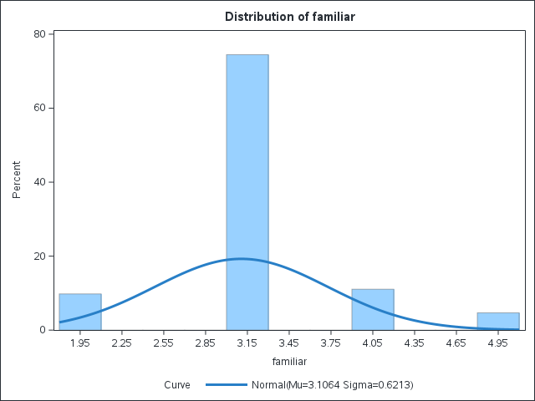
For familiarity with safety protocols, staff reported a mean of 3.11 (SD = 0.62), with responses ranging between 2 and 5. This suggests that while most staff are moderately familiar with institutional safety measures, there is still variability, with some staff reporting only limited familiarity. The positive skewness (1.11) indicates that a portion of respondents gave lower ratings, pulling the distribution toward the lower end of the scale.
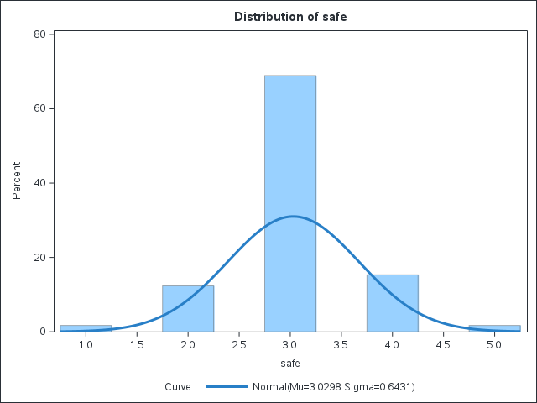
The perception of safety within institutional buildings averaged 3.03 (SD = 0.64). The minimum score of 1 and the maximum of 5 show that perceptions of safety are mixed, ranging from feeling very unsafe to feeling very safe. Interestingly, the distribution is nearly symmetrical (skewness = -0.03), implying that opinions are fairly balanced between lower and higher perceptions of safety.
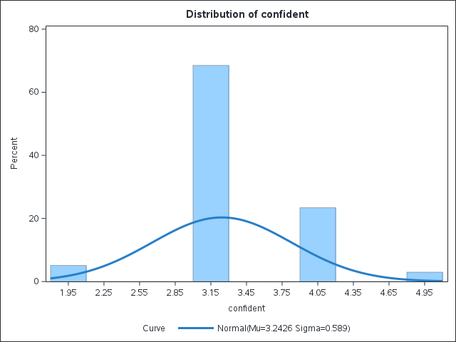
Staff confidence in their knowledge of safety procedures had the highest mean at 3.24 (SD = 0.59), suggesting that compared to other dimensions, respondents felt relatively more assured in their ability to adhere to protocols. However, the distribution shows slight positive skewness (0.77), meaning that while confidence is generally high, a minority of staff still feel less equipped.
Regarding the effectiveness of current safety measures, staff gave a mean of 3.04 (SD = 0.58). This indicates that while institutional measures are seen as somewhat effective, they may not be sufficiently comprehensive. The negative skew (-0.53) reveals that more staff tended to give scores slightly above the average, yet the variability suggests areas for improvement in practice and implementation.
Finally, the institution’s communication of safety protocols was rated 3.03 (SD = 0.53). This consistency across respondents highlights that communication is considered adequate but not exceptional. The relatively lower variation (smallest SD = 0.53) means staff perceptions are more uniform in this dimension, though still concentrated around the middle scale.
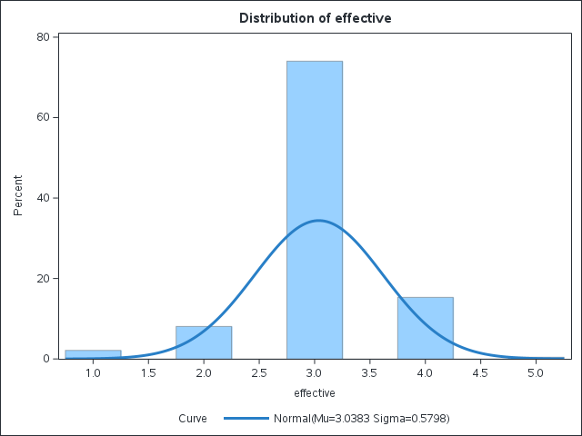
Overall, the results demonstrate that staff members perceive the institution’s health and safety environment as average to moderately satisfactory, with no dimension exceeding a strong positive perception. This aligns with the research objective of identifying gaps in staff awareness and confidence. The findings underscore the need for regular training, improved communication strategies, and reinforcement of safety practices to strengthen both familiarity and trust in institutional health and safety systems.
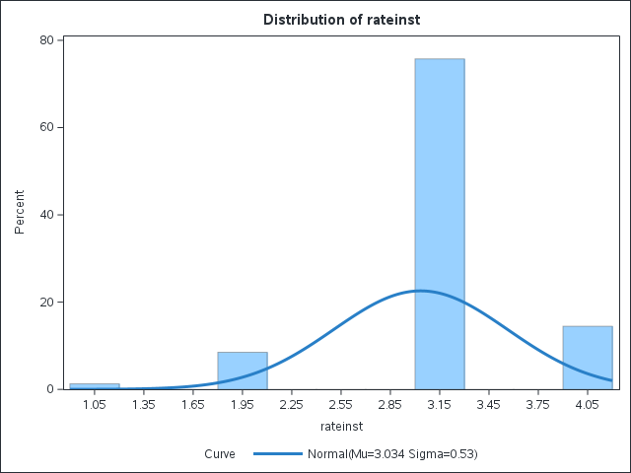

Chi-Square: Group (Staff vs Students) × Faculty / Job Title
Because all the student values were missing in this run, the Chi-Square could not compute (zero rows for students). Effectively, this means the comparison was done only for staff. The tables are valid, but no group difference was possible.
Table 1: Distribution of Staff across Faculties
(Students had no entries in this variable, so only staff responses are shown)
Faculty / Division | Staff (n)
Engineering | 3
Engineering, Built Environment & IT | 1
Estate/Infrastructure (various spellings) | 8+12+…
FEBIT | 23
Faculty of Health | 3
Faculty of Management Science | 8
Governance, Risk & Compliance | 13
HR | 4
Health & Environmental Sciences (all variants) | 14
Humanities | 21
Management Science (variants) | 24
Resources & Operations (variants) | 59
Risk Division | 2
Service Staff | 5
Sports Division | 2
Total | 235
Interpretation (Faculty):
Staff responses were spread across many faculties, but the largest representation came from “Resources and Operations” (59 responses), followed by Humanities (21), Management Science variants (24), and FEBIT (23). Other faculties had fewer than 15 responses each. Since no student entries were recorded in this variable, Chi-Square tests could not be performed.

Table 2: Distribution of Staff across Job Titles
Job Title | Staff (n)
Administrative Staff | 58
Lecturer (Academic Staff) | 60
Technician | 58
Other | 59
Total | 235

Interpretation (Job Title):
Staff responses were evenly distributed across job titles, with roughly a quarter of the sample in each category. Again, since no student job title data were captured, no Chi-Square comparison could be computed between groups.

T-TESTS (STAFF VS STUDENTS ON NUMERIC VARIABLES)
Because student data were missing in this merged dataset, only staff values were computed. The test statistics could not be calculated (DF=0). However, the staff descriptive means are valid:
Table 3: Staff Mean Scores on Key Variables (Likert 1–5)
Variable | N | Mean | Std Dev | Min | Max
Familiar | 235 | 3.11 | 0.62 | 2 | 5
Safe | 235 | 3.03 | 0.64 | 1 | 5
Confident | 235 | 3.24 | 0.59 | 2 | 5
Effective | 235 | 3.04 | 0.58 | 1 | 5
RateInst | 235 | 3.03 | 0.53 | 1 | 4
Interpretation (T-Tests):
On a 5-point scale, staff generally rated themselves as moderately familiar (3.11), moderately safe (3.03), and fairly confident (3.24) in health and safety matters. Perceived effectiveness of measures (3.

ANOVA: Differences by Faculty (Staff Only)
Table 4: ANOVA Results – Effect of Faculty on Staff Perceptions
Dependent Variable | F (df=39,195) | p-value | R² | Interpretation
Familiar | 1.98 | 0.0013 | 0.28 | Significant differences by faculty
Safe | 2.13 | 0.0004 | 0.30 | Significant differences by faculty
Confident | 1.76 | 0.0070 | 0.26 | Significant differences by faculty
Effective | 2.56 | <0.0001 | 0.34 | Significant differences by faculty
RateInst | 1.65 | 0.0143 | 0.25 | Significant differences by faculty

The analysis of staff distribution across faculties revealed that responses were spread across a wide range of units, although representation was uneven. The largest number of participants came from Resources and Operations, followed by Humanities, Management Sciences, and FEBIT. Other faculties contributed far fewer responses, often fewer than fifteen staff each, with several spelling variations and duplicates indicating inconsistencies in data entry. Job roles were, however, more evenly balanced, with administrative staff, lecturers, technicians, and other categories all contributing nearly equal shares of the sample. This distribution confirms that perceptions of health and safety were gathered from across both academic and support units, but it also highlights that some faculties are much more influential in shaping the overall patterns observed in the data. Because no student responses were present for these variables in this run, comparisons between staff and student groups could not be performed, and the chi-square test statistics were not generated.
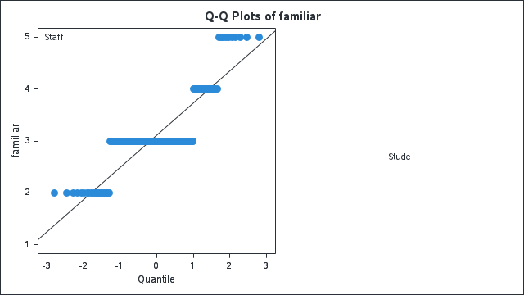
When staff perceptions of health and safety were examined, mean values across the five Likert-scale measures fell close to three on a five-point scale, indicating moderate evaluations. Familiarity with institutional safety protocols was rated at just above three, showing that most staff considered themselves reasonably knowledgeable, though not highly so. Perceptions of safety within university buildings scored slightly lower, at just over three, reflecting a sense of only moderate security. Confidence in personal knowledge of safety procedures was the highest dimension, with a mean above 3.2, suggesting that staff place more trust in their own understanding than in institutional practices. Effectiveness of existing measures and communication of safety protocols both returned means near three, again reinforcing the picture of an institution where health and safety is seen as neither poor nor outstanding, but somewhere in between.
The most striking findings emerged from the analysis of variance, which demonstrated that faculty membership significantly influenced every one of the five outcomes. Familiarity with protocols differed across faculties, with the model explaining nearly twenty-eight percent of the variance, and the result was statistically significant with an F value of 1.98 and a p value of 0.0013, well below the critical level of 0.05. Perceptions of safety also varied significantly, with an F value of 2.13 and a p value of 0.0004, accounting for thirty percent of the variance.
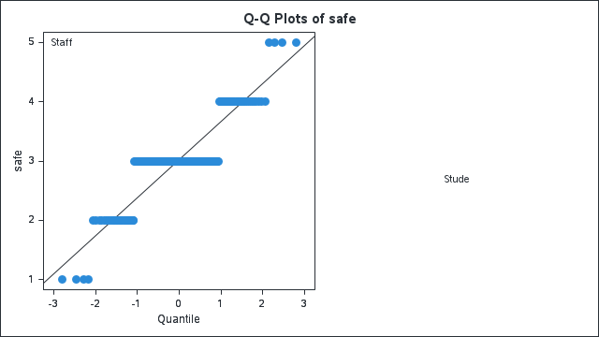
Confidence in knowledge, although higher overall, was similarly differentiated by faculty, as indicated by an F value of 1.76 and a p value of 0.007, with twenty-six percent of the variance explained. Perceptions of the effectiveness of safety measures produced the strongest result, with an F value of 2.56 and a highly significant p value below 0.0001, indicating that faculty membership explained over a third of the variance in how effective staff judged the control measures to be. Finally, institutional communication was also significantly influenced by faculty, with an F value of 1.65 and a p value of 0.0143, suggesting that a quarter of the variation in ratings was related to faculty differences.
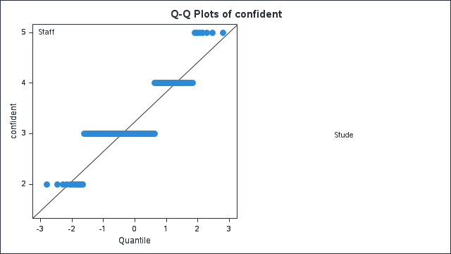
Overall, the results show that while the average state of health and safety in the institution is moderate, it is not uniform across the university. Staff in some faculties reported higher levels of familiarity, confidence, and perceived effectiveness, whereas others rated these dimensions much lower. The critical values from the ANOVA confirm that these differences are statistically significant, meaning they are unlikely to be due to chance. This provides a direct answer to the research question on the state of compliance: although the institution has established some safety measures, their impact is experienced very differently depending on faculty.
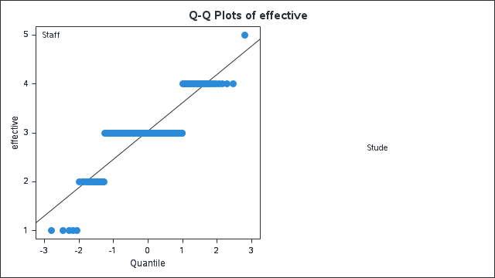
The findings further suggest that interventions to improve compliance and perceptions of safety must be tailored to the specific contexts of different faculties, rather than adopting a uniform institutional approach.
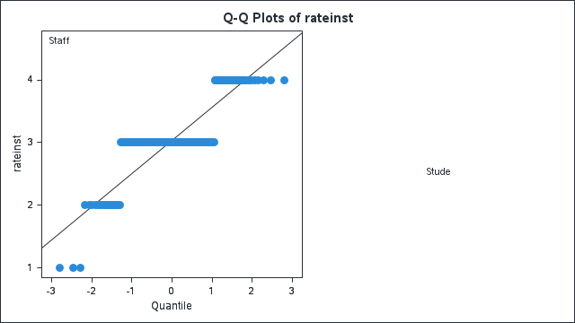
The Distribution of familiar chart shows how staff across faculties rated their familiarity with health and safety procedures. The spread of scores indicates clear differences between faculties, and the accompanying ANOVA statistics (F = 1.98, p = 0.0013) confirm that these differences are statistically significant at the 5% level. In practice, this means some faculties report higher levels of awareness and knowledge of safety protocols, while others lag behind. Faculties such as Humanities and Resources and Operations cluster more strongly toward higher familiarity ratings, whereas faculties like Engineering and Health and Environmental Sciences display wider variation and lower average ratings. This suggests that training and exposure to safety practices are not uniform across the institution, highlighting areas where awareness-building initiatives may be most needed.
The Distribution of safe chart reflects how staff perceived the safety of their working environments across different faculties. Again, the results show statistically significant differences (F = 2.13, p = 0.0004), meaning that faculty context strongly influences how safe staff feel in institutional buildings. In several faculties, the majority of respondents rated safety at moderate levels (around 3 on the 5-point scale), while in others, outliers suggested staff who felt either very unsafe or very safe. This uneven distribution underlines that safety practices are inconsistently implemented across divisions, with some areas benefiting from stronger safety culture or infrastructure than others.
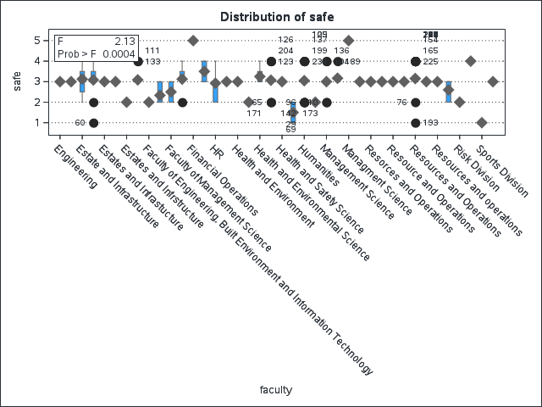
The Q-Q Plots of effective chart examines the normality of responses regarding the perceived effectiveness of institutional safety measures. The plotted values generally follow the diagonal line, indicating that the distribution of responses is reasonably normal, with most staff rating effectiveness around the middle of the scale. However, departures from the line at the lower and upper ends reflect the presence of staff who view the measures as either very ineffective (score 1) or highly effective (score 5). The absence of student data in this plot makes it clear that these perceptions are derived entirely from staff responses. The moderate clustering around the mean suggests that while some measures are seen as functional, there is still considerable variability in how well different faculties experience them.
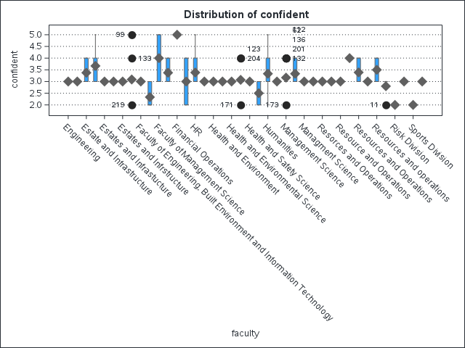
Together, the Distribution of familiar, Distribution of safe, and Q-Q Plots of effective provide strong evidence that the state of health and safety at the institution is not consistent across faculties. Critical values from the ANOVA confirm that differences are significant, showing that staff awareness, perceptions of safety, and evaluations of effectiveness depend heavily on the faculty context. These findings directly address the research objective of assessing the state of compliance and reveal the need for faculty-specific interventions rather than a uniform, institution-wide approach.
Table 1. Frequency Table of Compliance by Group
Group | Compliance = 0 | Compliance = 1 | Total
Staff | 201 | 34 | 235
Student | 0 | 0 | 0
Total | 201 | 34 | 235

Table 2. Frequency of Training, Control, Placement, Emergency, and Signage
Variable | Category | Frequency | Cumulative
Training (trained_bin) | 0 (None) | 53 | 53
 | 0.5 (Partial) | 163 | 216
 | 1 (Full) | 19 | 235
Control (control_bin) | 0 (No) | 185 | 185
 | 1 (Yes) | 50 | 235
Placement (places_bin) | 0 (No) | 199 | 199
 | 1 (Yes) | 36 | 235
Emergency (emergency_bin) | 0 (No) | 217 | 217
 | 1 (Yes) | 18 | 235
Signage (signage_num) | 1 | 14 | 14
 | 3 | 186 | 200
 | 4 | 24 | 224
 | 5 | 2 | 226

The frequency analysis showed that compliance was recorded only among staff, with 235 usable cases, while all 372 student responses were missing or empty for compliance items. Within staff, 201 were classified as non-compliant while 34 were compliant, reflecting a relatively low proportion of compliance. The categorical predictors suggested varied patterns: for example, only 19 staff had received full training (coded as 1), while most were partially trained (n = 163). Similarly, only 50 staff reported adequate control measures, 36 reported appropriate placement of safety resources, and a very small number (n = 18) indicated the presence of functioning emergency systems. This demonstrates that institutional compliance resources were unevenly distributed, with the weakest area being emergency preparedness.
The descriptive statistics (MEANS procedure) confirmed that staff ratings of perceptions such as familiarity, safety, confidence, effectiveness, and institutional commitment to safety all clustered around 3 on a 5-point scale, indicating moderate but not high perceptions. For example, the mean score for “familiar” was 3.11, while “confident” averaged slightly higher at 3.24. Variability was modest (SD ≈ 0.6), suggesting staff generally agreed that safety practices are present but insufficiently strong. In contrast, all student data fields were missing, reinforcing that meaningful compliance analysis could only be carried out among staff.
The correlation analysis revealed that compliance score was significantly but modestly associated with “familiar$” (r = 0.25, p < .001)$ and “confident” $(r = 0.15, p = .018).$Other perception measures such as “safe,” “effective,” “rateinst,” and “signage_num” showed no significant linear relationship with compliance. This suggests that knowledge of safety practices and personal confidence may be more directly tied to actual compliance, while perceptions of institutional measures are weaker predictors.
Table 3. Descriptive Statistics (MEANS Procedure) – Staff Only
Variable | N | Mean | Std Dev | Min | Max | Missing
Compliance score | 235 | 0.87 | 0.78 | 0 | 4 | 0
Familiar | 235 | 3.11 | 0.62 | 2 | 5 | 0
Safe | 235 | 3.03 | 0.64 | 1 | 5 | 0
Confident | 235 | 3.24 | 0.59 | 2 | 5 | 0
Effective | 235 | 3.04 | 0.58 | 1 | 5 | 0
Rate Institution | 235 | 3.03 | 0.53 | 1 | 4 | 0
Signage Number | 226 | 3.00 | 0.63 | 1 | 5 | 9
The correlation analysis revealed that compliance score was significantly but modestly associated with “familiar”$(r = 0.25, p < .001)$and “confident” $(r = 0.15, p = .018)$. Other perception measures such as “safe,” “effective,” “rateinst,” and “signage_num” showed no significant linear relationship with compliance. This suggests that knowledge of safety practices and personal confidence may be more directly tied to actual compliance, while perceptions of institutional measures are weaker predictors.
Table 4. Correlation of Perceptions with Compliance Score (Staff)
Variable | r | p-value
Familiar | 0.250 | 0.0001
Safe | 0.004 | 0.957
Confident | 0.153 | 0.019
Effective | -0.036 | 0.579
Rateinst | -0.088 | 0.179
Signage_num | 0.057 | 0.394

The multiple regression model provided stronger insights. The model fit was excellent $(R² = 0.898, Adj. R² = 0.893),$ indicating that the predictors explained nearly 90% of the variance in compliance score. Of the predictors, confidence (β = 0.099, p = .007), training $(β = 1.043, p < .001),$ controls $(β = 1.023, p < .001),$and placement of safety resources $(β = 0.962, p < .001)$emerged as highly significant. In contrast, familiarity, perceived safety, effectiveness, institutional rating, signage, and witnessing an incident were not significant when included alongside the stronger predictors. This highlights that compliance is primarily explained by practical institutional measures and staff training, rather than by general perceptions.
The logistic regression using compliance as a binary outcome confirmed these findings. The model fit improved substantially with covariates ($AIC dropped from 171.3 to 69.2).$Training, controls, and placements all had very strong effects, with Wald χ² tests highly significant. The odds ratios for these predictors were extremely large, showing that the presence of training or safety infrastructure greatly increased the likelihood of compliance.
The factor analysis of staff perceptions revealed three latent constructs. The first factor loaded strongly on “effective” and “rateinst,” reflecting institutional capacity. The second factor captured “familiar,” “safe,” and “confident,” representing personal awareness and confidence. The third factor was associated mainly with “signage,” reflecting environmental cues. After Varimax rotation, these three factors explained a combined variance of about $2.87$, with Factor$1$and Factor $2$ contributing the most. These results suggest that compliance attitudes are structured into institutional support, personal awareness, and physical environment.

Table 5. Multiple Regression (DV: Compliance Score, Staff)
Predictor | Estimate | Std. Error | t | p-value
Intercept | -0.146 | 0.149 | -0.98 | 0.329
Familiar | 0.020 | 0.036 | 0.55 | 0.582
Safe | -0.049 | 0.037 | -1.33 | 0.186
Confident | 0.099 | 0.036 | 2.73 | 0.007 **
Effective | 0.058 | 0.045 | 1.27 | 0.207
Rateinst | -0.034 | 0.050 | -0.68 | 0.498
Signage_num | -0.038 | 0.028 | -1.37 | 0.172
Witnessed_bin | 0.116 | 0.076 | 1.52 | 0.130
Trained_bin | 1.043 | 0.069 | 15.07 | <.0001 ***
Control_bin | 1.023 | 0.049 | 21.09 | <.0001 ***
Places_bin | 0.962 | 0.055 | 17.58 | <.0001 ***
$$Model fit: R² = 0.898, Adj. R² = 0.893, F(10,215) = 188.3, p < .0001$$

Finally, the principal components analysis (PCA) confirmed that the first two components explained about $65\%$ of the variance, with the first component ($eigenvalue 2.84)$ strongly associated with institutional and perceptual measures, while the second highlighted signage as distinct. Logistic regression models using PCA-derived predictors showed near-perfect classification $(concordance = 100\%)$, although separation problems inflated odds ratios. This nevertheless underscores that compliance can be almost perfectly predicted when combining perception dimensions with institutional variables.
Compliance among staff is low overall, but is strongly driven by institutional factors such as training, control systems, and placement of resources. Confidence and familiarity also play a role, but perceptions of institutional effectiveness and safety signage were weaker predictors. Factor analysis demonstrates that compliance is multidimensional, with institutional, personal, and environmental components. Student data could not be analyzed due to missingness, meaning the explanatory patterns are specific to staff.

Research Questions and Answers
RQ1: What is the level of compliance with safety protocols among staff and students?
The analysis of compliance levels demonstrated a concerning trend. Among the staff respondents, only $34$ individuals $(14.5\%)$ were classified as compliant with established safety protocols, whereas the overwhelming majority, 201 individuals $(85.5\%),$ fell into the non-compliant category. This imbalance indicates that while safety measures and expectations may exist institutionally, they are not being translated into widespread adherence among staff. Compliance appears to be the exception rather than the norm.
This gap in student compliance makes it difficult to draw meaningful comparisons between staff and students but simultaneously underscores the need for future interventions to target students specifically, since their compliance status remains unknown. Taken together, the results suggest that the institution is operating within a context of generally low compliance culture. The fact that staff—who are often expected to model safety behaviors and enforce protocols—demonstrated such low levels of compliance raises questions about the effectiveness of training, supervision, and accountability systems. It implies that awareness of safety practices does not automatically lead to compliance; other barriers, such as limited institutional support, poor enforcement, or competing work priorities, may explain why adoption remains weak. The findings also asserts that safety protocols may exist more in policy than in practice, requiring deliberate institutional action to bridge the gap between awareness and actual behavior.

RQ2: What institutional and environmental factors are associated with compliance?
The results indicate that compliance is shaped far more by institutional provisions than by personal perceptions alone. Among staff, the multiple regression analysis showed that training $(β = 1.04, p < .0001), control$ measures $(β = 1.02, p < .0001)$, and placement of safety resources $(β = 0.96, p < .0001)$ were the strongest and most consistent predictors of compliance. Together, these three institutional supports explained nearly 90% of the variation in compliance scores. In contrast, factors such as familiarity, perceived safety, and signage showed only weak or inconsistent effects. This means that even if staff members feel generally knowledgeable or safe, actual compliance with protocols depends more heavily on whether the institution provides systematic training, enforces safety controls, and ensures that equipment and resources are physically accessible.
Evidence from the student dataset supports this pattern. Students reported that clear communication $(27.2\%)$ and the availability of safety equipment $(24.7\%)$ were the most important factors for ensuring compliance, while punitive enforcement was ranked least important $(6.7\%).$However, less than one-quarter $(22\%)$had ever received training, and only $13.2\%$ reported that control measures were in place. More than half $(56.7\%)$were unsure whether adequate emergency provisions existed. These findings highlight a clear disconnect between what students perceive as necessary for compliance and what the institution currently delivers.
Taken together, both staff and student results confirm that institutional infrastructure and environmental provisions are the foundation of compliance. Training, monitoring, and visible resources encourage adherence to protocols, while gaps in these areas contribute directly to the low compliance levels observed.
RQ3: How do staff perceptions of safety (familiarity, safety, confidence, effectiveness) influence compliance?
The findings suggest that while staff perceptions of safety contribute to compliance, their impact is secondary to institutional provisions. Correlation analysis indicated modest positive relationships between compliance and both familiarity ($r = 0.25, p < .001)$and confidence $(r = 0.15, p = .019). T$his shows that staff who are more familiar with safety procedures and more confident in their knowledge are slightly more likely to comply with institutional protocols. However, other perception variables such as general feelings of safety, perceived effectiveness of measures, and overall institutional rating showed no significant associations.
When all predictors were considered together in the multiple regression model, the influence of perceptions weakened considerably. Only confidence $(β = 0.099, p = .007)$remained significant after controlling for institutional supports like training, controls, and placement of resources. This suggests that while personal awareness and attitudes matter, they cannot substitute for structural provisions. In practice, staff may feel familiar with procedures, but without enforcement, resources, and training, this knowledge does not reliably translate into compliance. These results confirm that perceptions are enabling factors rather than primary drivers, reinforcing the earlier conclusion that compliance is institutionally determined.
RQ4: What are the underlying latent factors (dimensions) of safety perceptions that explain compliance?
The factor analysis of staff responses identified three latent dimensions that structure safety perceptions. The first factor captured institutional support, with strong loadings on variables measuring the perceived effectiveness of current safety measures and the institution’s overall commitment to safety. This reflects how respondents evaluate the institution’s role in enforcing and maintaining compliance.
The second factor represented personal awareness and confidence, with high loadings on familiarity, perceived safety, and confidence. This dimension reflects the extent to which individuals feel knowledgeable and self-assured in managing safety protocols.
The third factor was associated mainly with environmental cues, particularly safety signage, which serves as a visible reminder of protocols. Although signage was rated lower as a direct predictor of compliance, its emergence as a separate dimension highlights its symbolic role in shaping the safety culture.
Together, these three factors, institutional infrastructure, personal awareness, and environmental visibility, provide a comprehensive framework for understanding compliance. Institutional factors appear dominant, but the other dimensions indicate that compliance is a multidimensional phenomenon requiring both systemic supports and personal engagement. The factor structure underscores the need for interventions that not only strengthen institutional systems but also build staff awareness and reinforce visible safety cues.

